**Smart Bus ticket system using QR code in android app**

Abstract:

In this paper, we are proposing QR reader for bus ticket. Users can scan QR reader instead of ticket. In this app, after registration profile, we have to attach our bank details through in this app. Then whenever we are going on bus, we have to select from and to location. Then it will generate amount details for per head. After that we have give passenger details. Passenger’s details mean count. Then we can scan QR code. So directly money will transfer from our bank details. Then we can get SMS alert for ticket payment proof. Then admin (Conductor) side, they calculate amount details through using web application. Then they can calculate per day amount details for bus ticket information. Then admin can generate per day 3 hours report for checking that crowd condition.

**Existing System:**

In the general way, every bus is controlled by a conductor. The conductor will collect money from each passenger and issue ticket. Initially, printed papers or tokens are used as tickets. Nowadays, handheld machines are used to print tickets. This system has many disadvantages. The passenger have to carry the ticket till the end of travel, the conductor should ensure that everyone has got the ticket, [3]the time taken for ticketing is comparatively more and more amount of paper is needed to print the Ticket. Nowadays conductors are trained to operate the handheld ticketing machine. For example, if a passenger wish to travel in bus. He has to carry money with him. Then conductor will collect the money and he will give ticket. This has to repeat for all passengers. This will take more time and waste of human resource as well as energy. Even handheld ticketing machine is comparatively slow and need trained person to operate it.

In Existing system RFID Reader is used to read the RFID tag but destination should be entered by passenger in keyboard , So that amount will be debited automatically from the tag. Here if once destination is arrived, bus stops automatically and intimate with buzzer sound. Fairly such arrangement consumes more time in case of accessing of tag by every individual, so to overcome that, implementation of ticketing system without access is developed in this proposal with addition of application to transfer information about accident occurrence.

**Disadvantage:**

1. Hardware debugging is the major problem.
2. We fabricated all the components in PCB and test power supply; input and output.
3. If the ports are not working then check the code and rework in hardware.

**Proposed System:**

In proposed method, we are introducing QR reader. Here, we will create one android application for select travelling route and generate amount. After generating amount, user has to read that QR image. Then automatically it will send amount from our bank details or wallet. Each conductor having one QR reader and after reading that values automatically it will store in database. Then user will get message for travelling ticket.

**Advantage:**

1. No hardware debugging.
2. No change (Amount) problem.

**System Architecture:**

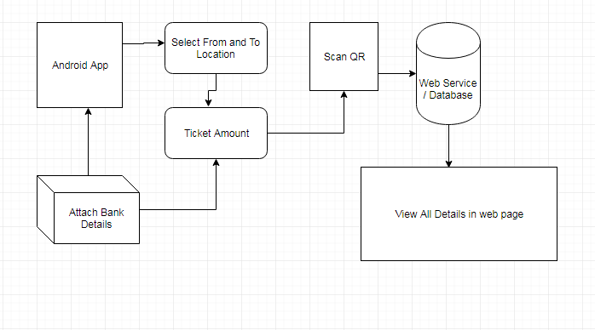

**Hardware and Software Requirements:**

**Hardware:**

1. OS – Windows 7, 8
2. RAM – Min 4GB
3. Android Mobile

**Software:**

1. JDK
2. Android Eclipse (ADT-Bundle)
3. Net beans IDE
4. Mysql and SQLyog